
Western New York BloodCare
Michael Tuberdyck Scholarship Application
Repeat Applicants

Michael R. Tuberdyck
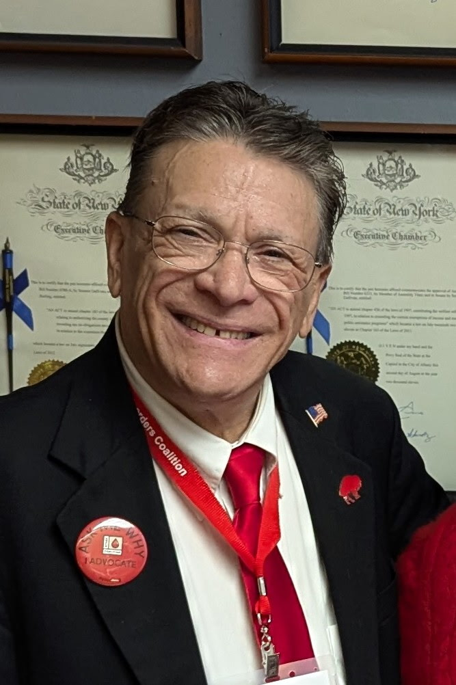
This scholarship is dedicated in honor of Michael Tuberdyck, whose journey exemplified resilience, courage, and advocacy. His experience as a patient within Western New York BloodCare and the entire bleeding disorders community left a lasting impact on those who cared for him and continues to inspire our commitment to compassionate, patient-centered care.
Michael faced severe hemophilia with remarkable strength, grace, and determination. Throughout his life, he demonstrated the profound importance of advocacy, empathy, and community support.
His story reminds us that behind every diagnosis is a person whose life, goals, and relationships matter deeply. The legacy of Michael Tuberdyck is one of hope and it serves as a guiding force for this scholarship.
This scholarship reflects the values embodied by Michael, by supporting individuals who have a similar story of his own and who demonstrate a commitment to the bleeding disorder community and fierce advocacy.
Through this scholarship, Michacel’s story lives on — not only in memory, but in action. Each recipient becomes part of a living tribute, carrying forward the values that defined Michael Tuberdyck and translating them into meaningful service, learning, and care for others.
This dedication stands as a reminder that one life can inspire many, and that compassion, when invested in education and service, creates a legacy that endures.

Scholarship Overview
The Western New York BloodCare (WNYBC) Scholarship Program supports individuals affected by bleeding disorders pursuing vocational, undergraduate, or graduate education. Awards support academic achievement and professional development.

Eligibility Requirements
- Applicant must be a WNYBC patient in good standing.
- Applicant must be a high school senior, graduate, or enrolled full‑time in higher education.
- Must meet academic threshold (80% high school average or GPA ≥ 2.5).
- Recipients may reapply annually; renewals are not guaranteed.

Scholarship Categories
- Vocational Programs
- Undergraduate Programs
- Graduate Programs

Selection Criteria
- Academic performance
- Quality of written responses
- School and community involvement
- Work and/or Volunteer experience

Submission Instructions
Deadline Annually: March 31st
Submit completed applications and required materials to:
Scholarship Committee
Western New York BloodCare
1010 Main Street, Suite 300
Buffalo, NY 14202
Or
Scholarships@wnybloodcare.org

Applicant Information
Full Name
Preferred Name
Preferred Pronouns
Email
Address
City
State
Zip Code
Phone
Date of Birth
College/University/Vocational Program (Fall-Upcoming Year)
Grade/Class Level (Currently)
Anticipated/Declared Major
Previous WNYBC Scholarship Recipient?
If Yes, When

Goal and Reflections
The following essay should reflect your current academic year and goals for the future. Your response must be detailed, highlight any achievements, and describe your plans for the future. Responses must be typed.
- Describe any challenges or obstacles you have faced over the past year or since your last application. Describe any achievements or accomplishments.

- Describe your current academic and personal goals. Highlight if your goals have changed since your last application and why.

Transcript Requirement
An official transcript must be submitted directly from your school or institution.
Unofficial transcripts will not be accepted.

Applicant Certification
I certify that all information provided in this application is accurate. I understand that providing false or misleading information may result in the denial or termination of scholarship funding.
Signature: ____________________________________________________________________________________
Date: __________________________

